EXPERIMENT-5
Aim
To develop a cloud-based SIMATS Library Book Reservation Application using Zoho Creator that allows students to reserve library books online and manage reservations through the cloud.
Software Used
- Zoho Creator
- Web Browser (Chrome/Edge)
- Zoho Cloud Platform
Algorithm
- Open Zoho Creator.
- Create a new application named SIMATS Library Book Reservation System.
- Add the required fields.
- Enter student and book details.
- Click Submit.
- Store reservation details in the cloud database.
- Display reservation confirmation.
Output:
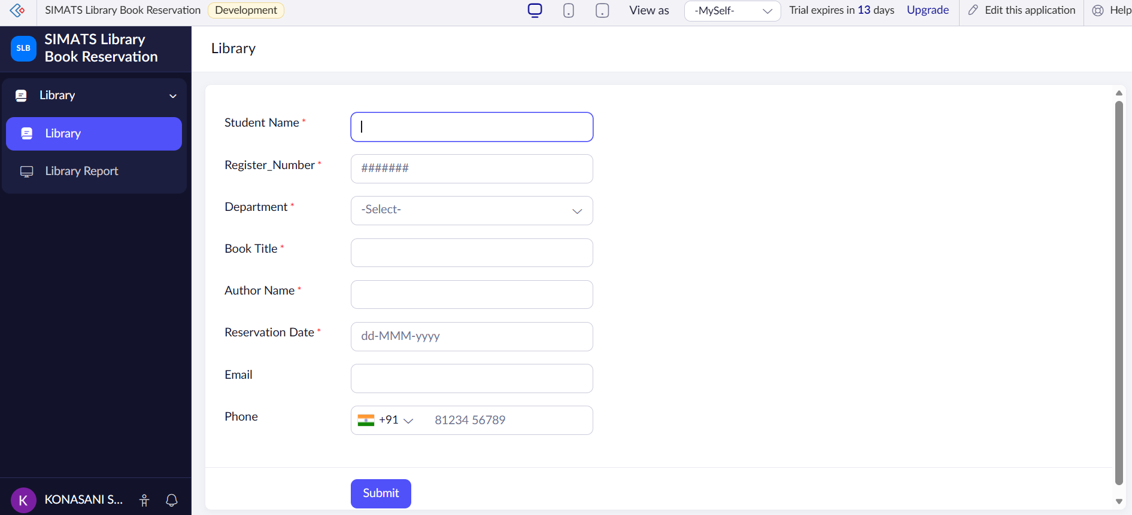
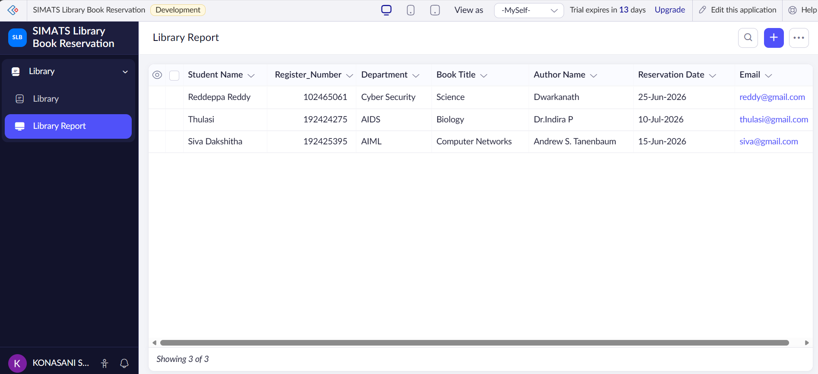

Result
The SIMATS Library Book Reservation Application was successfully developed using Zoho Creator SaaS. The system enables students to reserve library books online, stores reservation details in the cloud, and provides reservation confirmation.

